Utilizing Emulab for Machine Learning Resource Pool

Gi-Beom Song, Man-Hee Lee

Dept. of Computer Enginnering, Hannam University
70, Hannam-ro, Daedeok-gu
Daejeon, Republic of Korea
ssonggibum@gmail.com, manheelee@hnu.kr

Abstract

Recently, with the development of GPU (Graphics Processing Unit), the number of cores for GPGPU (General-Purpose computing on Graphics Processing Units) has increased rapidly with the performance of GPU. These developments lead to the attention of artificial intelligence, which was difficult to use in real situations due to too long learning time. As a result, artificial intelligence has been actively applied and studied in various fields such as natural language processing, image recognition, and autonomous navigation. However, it is impossible to use GPU without CUDA (Compute Unified Device Architecture) for parallel processing of machine learning because it requires CUDA-enabled GPU to parallelize the learning.
Therefore, researchers who have difficulty building a CUDA enabled GPU environment cannot help but rely on the CPU environment. Therefore, we propose to use Emulab as a resource pool for machine learning for those who have to depend on the CPU environment.

Keywords-component; Machine Learning, Distributed learning, Emulab, Replaced Learning

I. Introduction

Artificial intelligence is an intelligence created by a machine that enables a computer to do human learning ability, thinking, and self development so that it has similar intelligence to a person. In order to create such an artificial intelligence, artificial neural network is utilized to imitate the decision process in the human brain.
To create a sophisticated artificial neural network, the data is repeatedly computed according to the layer of the artificial neural network to improve the accuracy. For this reason, GPUs that perform simple operations with a larger number of cores show faster learning time than CPUs that perform sequential operations using a limited number of cores. However, if there is only GPUs without CUDA, one cannot but use CPU. Even in an environment that depends on the CPU environment, the learning time can be shortened by constructing the cluster environment and performing the learning in parallel. However, not everyone can build a parallel/distributed environment on his or her own.
To solve these problems, one can use cloud-based machine learning services like Amazon's Amazone Machine Learning (AML), Microsoft's Azure Machine learning, IBM's Statistical Package for the Social Sciences (SPSS), and Google's Google Prediction API [1][2][3][4]. AML has the advantage of helping users solve problems even if they do not understand the machine learning algorithm[1]. Azure machine learning supports the drag-and-drop method, so you can use it without typing commands, and you can add Python or R language modules as data acquisition sources[2]. IBM's SPSS offers a point-and-click interface that is easy to use and has excellent performance[3]. The Google Prediction API provides predictions and categorization of the supervised learning data and provides various APIs such as Google Cloud Vision, Google Speech, Google Natural Language, and Google Cloud translate API[4]. However, since these free functions of the services are limited, one must pay a large fee to solve real problems using all the functions and resources of the service.
To alleviate this burden, we propose to use Emulab, which was proposed and implemented at the University of Utah and is currently in use throughout the world as a research framework [5]. KREONet in Korea has also built and operated an Emulab, and it has been used in education and research. Emulab provides on-demand allocation of the OS environment and network settings that users want using hundreds of PCs and high-performance network switches. Users who already have an account in Emulab can use the cluster by allocating resources, so called Swap-In, for a short time without having to build their own physical clusters. When an experiment on the cluster ends, the cluster’s resource should be returned to Emulab, so called Swap-Out. The advantage of Emulab is that one can simply to swap-in the swapped-out system to resume an existing research because Emulab restores earlier cluster environment in some minutes.
In this paper, we propose an alternative learning method to utilize Emulab's resources for machine learning, which will give many benefits to researchers who can not construct a GPU environment for machine learning. In addition, we compare the learning results of a single environment and a distributed environment constructed in Emulab, showing using Emulab as a resource pool for machine learning very helpful. Finally, we propose a library architecture to rapidly utilize Emulab for machine learning.

II. Related work

- Artificial Neural Network

The artificial neural network is a computing system inspired by biological neural networks that make up the animal's brain. It has a problem-solving ability through the weight of the synapses whose network formed by the connection of each neuron (Synapse) is changed by the learning of the neuron[6]. Neurons are composed of several layers of synapses between different neurons in each layer shown in Fig. 1. The number of neurons and the number of layers in each structure depends on the designer of the neural network or the type of data to be learned.

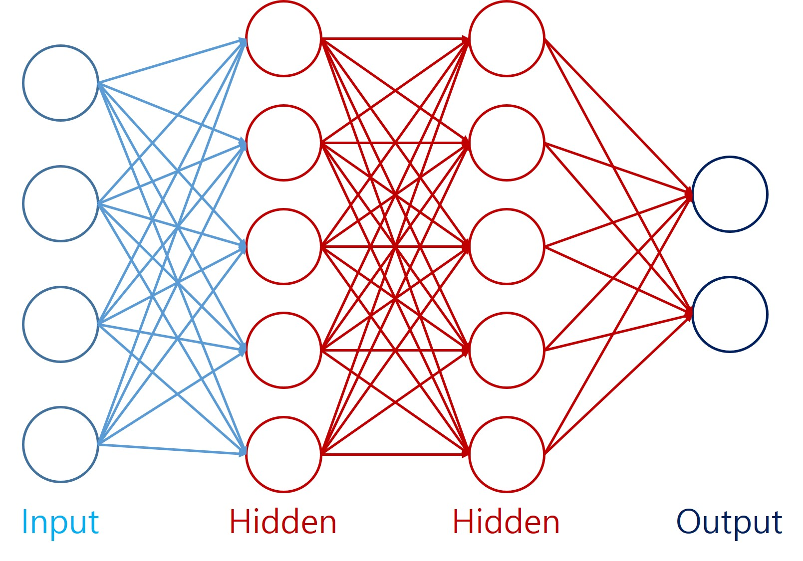
Figure 1. Artificial Neural Network Example

Neurons in the input layer receive input data values for training, and neurons in the hidden layers multiply its weight values and the values delivered in the input layer, and use the value for the input of its activation function to decide a value to be transferred to the next layers’ neurons. After repeating this process for the number of layers, the final value is derived in the output layer, and the error can be calculated by comparing with the correct answer of the training data. Forward propagation is used to update the weights of each layer from the input layer, and in the back propagation, each layer’s weight is calculated by propagating from the output layer to the input layer.

- Distributed Learning Techniques in Tensorflow

Tensorflow is an open source machine learning library developed by the Google Brain team for the purpose of studying machine learning and deep neural network [7]. Tensorflow provides a user-friendly interface through a data flow graph, and automatically processes derivative calculations when defining the calculation structure and objective function. In particular, it has a strength that does not require modification of source code to operate in CPU or GPU mode. However, Tensorflow's GPU mode can not be used with GPUs that can not be supported by CUDA or GPU mode with Compute Capability less than 3.5.
The Tensorflow library provides two distributed learning techniques called Model parallelism and Data parallelism. The Model parallelism method divides the parameters and shares the training data among nodes as shown in Fig.2. In this model, weight needed for computation during forward and back propagation must be communicated through machine communication. Therefore, it is considered that Model parallelism is suitable for environment where data is exchanged between GPU devices rather than network-based data exchange.
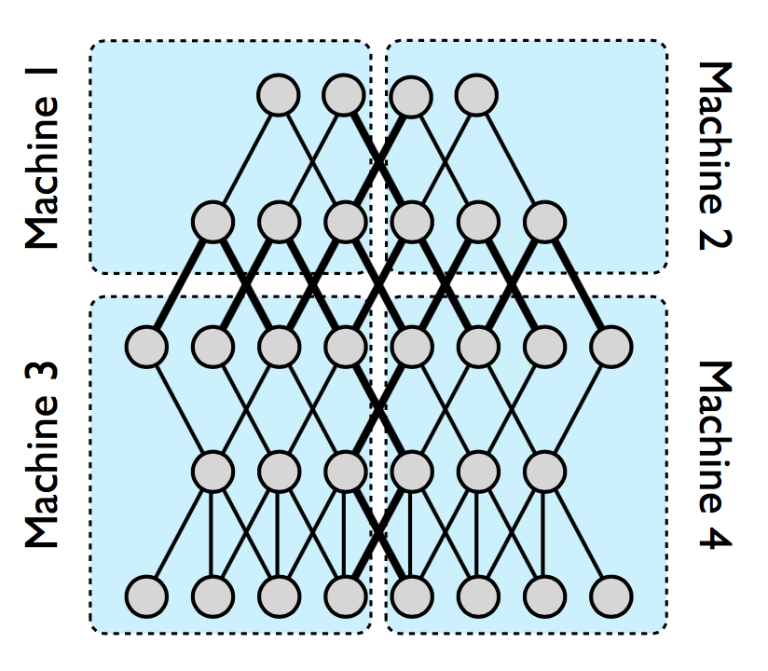
Figure 2. Model Parallelism

Data parallelism, in contrast to Model parallelism, divides training data and shares parameters as shown in Fig. 3. Model replicas send to the parameter server the slope gained from each training. The parameter server that receives the slope data merges and updates the slope data, allowing the model replicas to update the new parameter data. The cycle in which data must be transferred between different devices is longer than Model parallelism, and each replica can learn independently of other replicas.

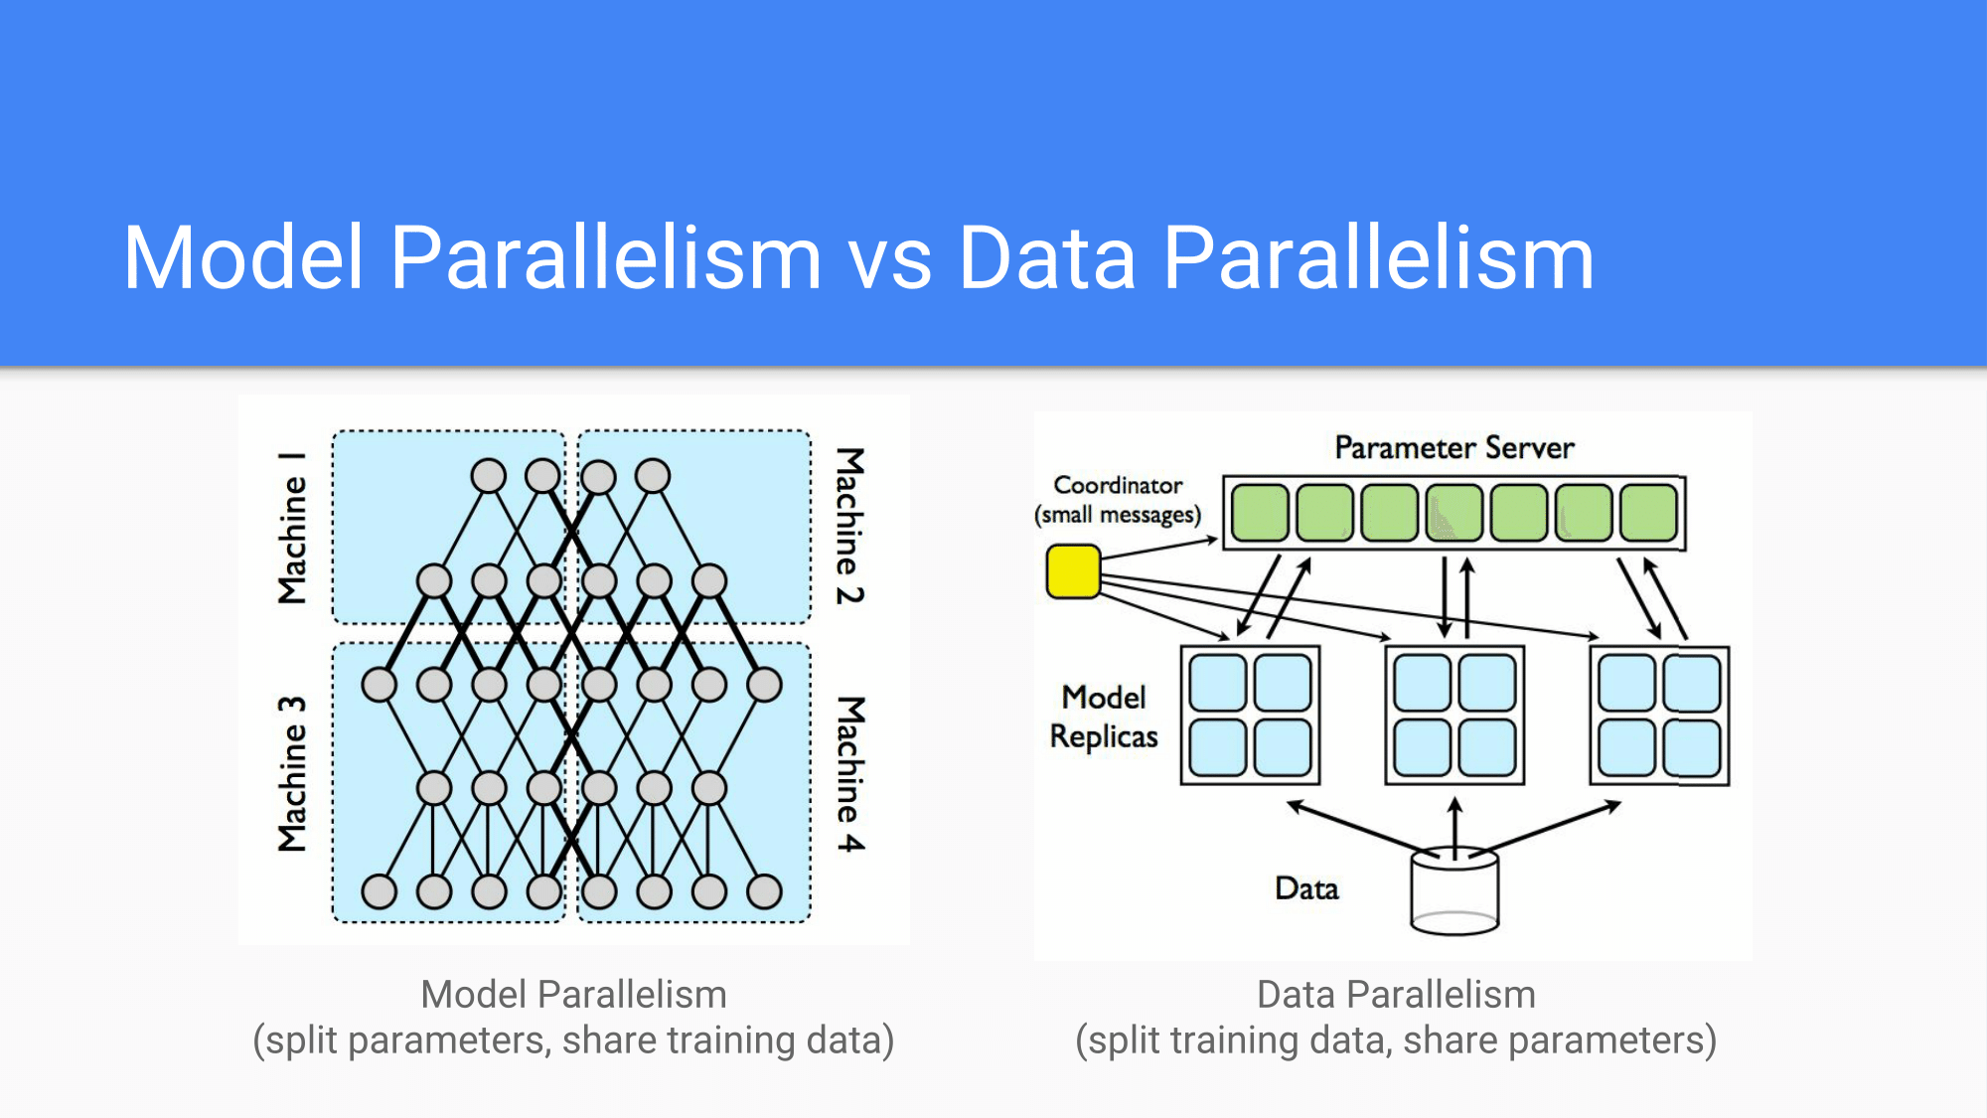
Figure 3. Data Parallelism

III. Experiment

In order to compare the difference between learning in a distributed environment and in a single PC using Emulab, we designed and utilized a distributed environment consisting of one parameter server and five workers.
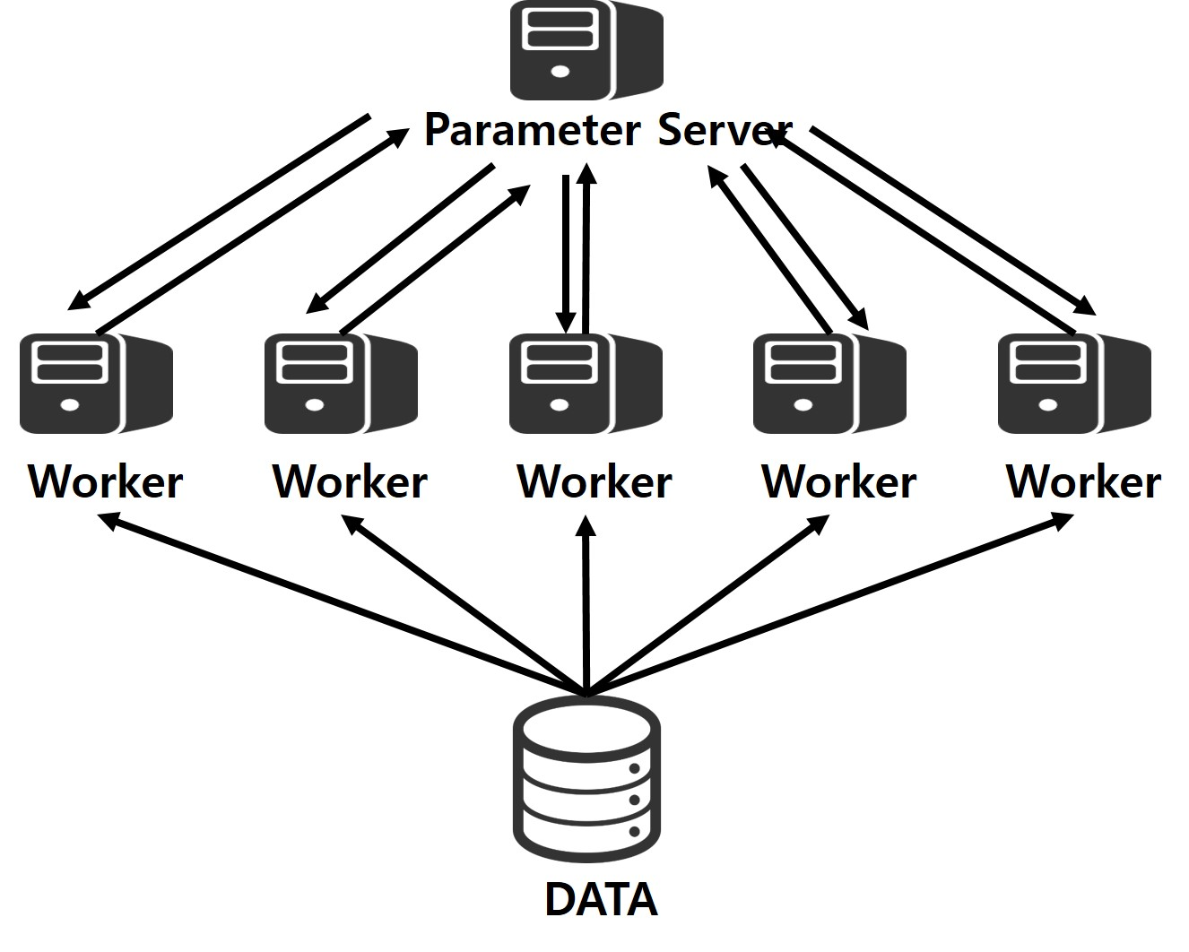
Figure 4. Distributed Environment Utilizing Emulab

We have solved the Computer Vision problem of learning handwritten images called MNIST (Modified National Institute of Standards and Technology) database in both environments in order to compare the performance of distributed and single-node environments [8]. We used CNN (Convolutional Neural Network) to extract features from the input data [9]. We tested a total of 50 epochs, and each epoch was configured to train 200 batch sizes 100 times, finally learning one million data.
Experimental results show that for a single node generated by Emulab, it took 2,978 seconds to learn a network with 98.99% accuracy as shown in Fig. 5. In contrast, in a distributed environment, a network with 99.01% accuracy was formed in 884 seconds as shown in Fig. 6. From the results, we can say that the learning of six nodes of Emulab is 3.5 times faster than the learning of a single node. It cannot be a big speed-up to get 3.5 times speed-up instead of six times using six times the number of nodes. However, we think that it is very meaningful for Emulab users or researchers who are considering using Emulab to be able to solve a large problem that can not be done in signle node with relatively fast speed when there is idle resource in Emulab.

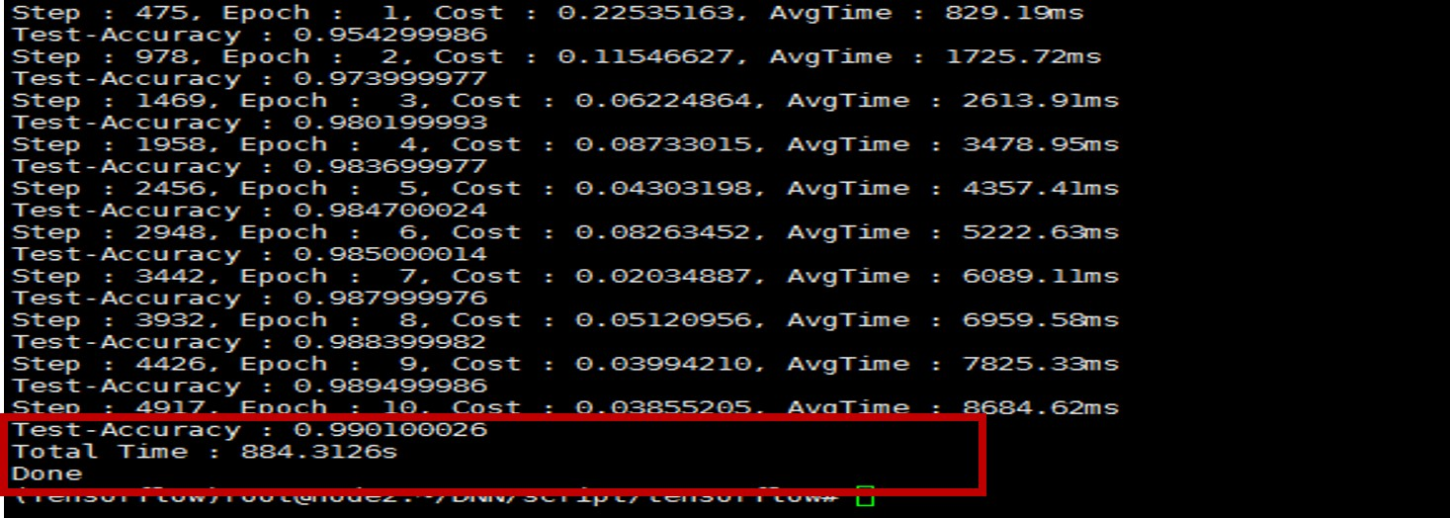
Figure 5. Result of Single Node

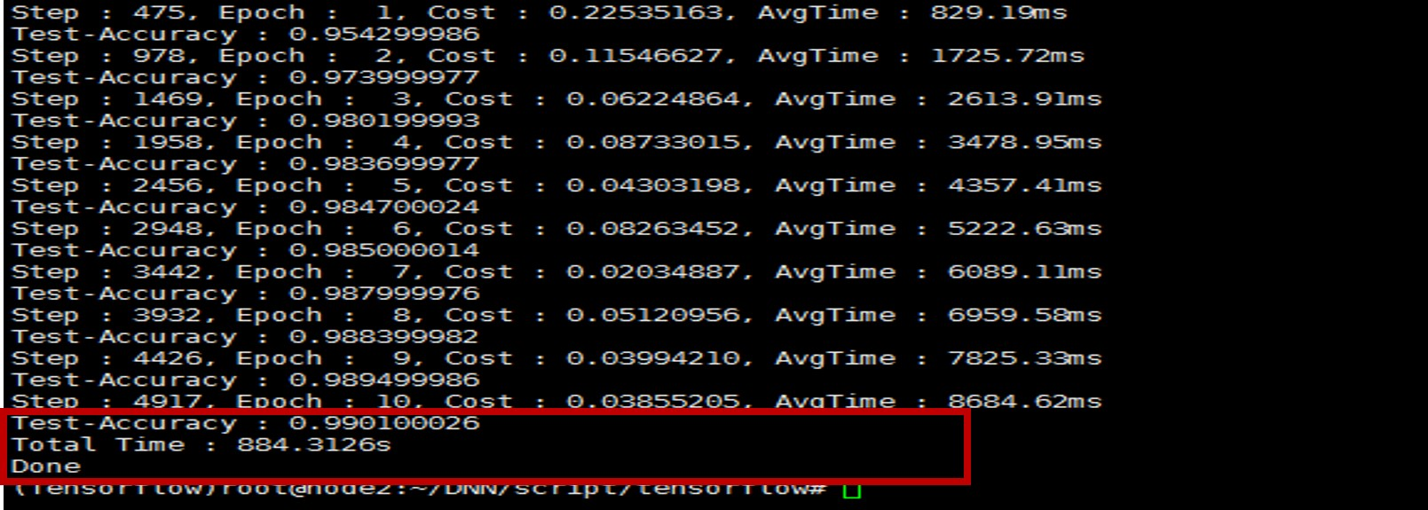
Figure 6. Result of Distributed Environment

IV. Library Architecture for Resource Pool of Machine Learning Utilizing Emulab

In previous sessions, we showed that it is efficient to use Emulab's distributed environment for machine learning. However, in order to utilize Emulab as a distributed environment for machine learning, it is necessary for users to log in as Emulab's account, create nodes to construct a distributed environment, and perform an environment setting procedure for machine learning all by himself or herself. Moreover, they need to have knowledge of Tensorflow for conducting distributed learning.
In order to prevent any delays and trial-and-error that can occur to prospective researchers, we propose a library architecture as shown in Fig. 7. The library provides a total of four functions. First, the Account Authencating function simplifies the procedure of authenticating accounts directly through KREONET's Emulab web page with a single function call. Second, the Node Creating function automates node creation for distributed environments. Third, the Environment Setting function configures the environment needed to perform Tensorflow based disbuted analysis on the generated node. Finally, the Training function performs learning in a distributed node using user-specified training models and data, and provides the user with the progressed learning results. If a prospective user gets an Emulab account, he or she can save time and effort by using the proposed library in order to utilize Emulab for machine learning in a distributed environment.

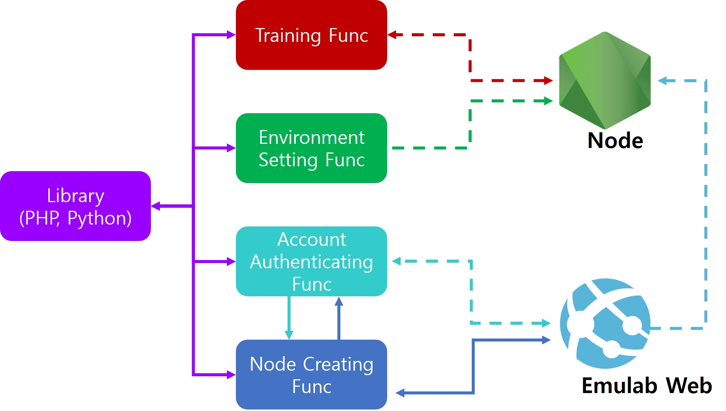
Figure 7. Library Architecture
V. Conclusion

To demonstrate the effectiveness of Emulab as a resource pool for researchers who have limited resources available for machine learning, we compared empirically the difference between learning in a distributed environment and a single environment in Emulab. The experimental results show that it is much faster to perform the machine learning in the distributed environment of Emulab than in the sigle node. In addition, we also proposed a library architecture to prevent trial and error that new Emulab users might face while constructing a distributed environment for machine learning. We hope this library will help Emulab's idle resources to be easily utilized for the machine learning service.

References

[1] Amazon, “Artificial.Intelligence on AWS”, https://aws.amazon.com/amazon-ai/
[2] Microsoft Azure, “Azure Machine Learning Studio”, https://azure.microsoft.com/en-us/services/machine-learning-studio/
[3] IBM Analytics, “IBM SPSS – IBM Analytics”, https://www.ibm.com/analytics/us/en/technology/spss/
[4] Google Cloud Platform, “Google Cloud Prediction API Documentation”, https://cloud.google.com/prediction/docs/
[5] M.Lee and W. Seok, “Research on the Trend of Utilizing Emulab as Cyber Security Research Framework”, Journal of the Korea Institute of Information Security and Cryptology. Pp. 1169-1180. Dec. 2013
[6] N. Gupta “Artificial Neural Network,” Network and Complex System, vol. 3, No. 1, pp. 24-28, 2013.
[7] M. Abadi, P. Barham, J. Chen, Z. Chen, A. Davis, J. Dean, M. Devin, S. Ghemawat, G. Irving, M. Isard, M. Kudlur, J. Levenberg, R. Monga, S. Moore, Derek G. Murray, B. Steiner, P. Tucker, V. Vasudevan, P. Warden, M. Wicke, Y. Yu, and X. Zheng “Tensorflow: A system for Lage-Scale Machine Learning,” 12th USENIX Symposium on Operating Systems Design and Implementation(OSDI), Nov, 2016.
[8] L. Deng, “The MNIST Database of Handwritten Digit Images for Machine Learning research [Best of the Web]”, IEEE Signal Processing Magazine, vol. 29, No. 6, pp. 141-142, Nov, 2012.
[9] J. Gu, Z. Wang, J. Kuen, L. Ma, A. Shahroudy, B. Shuai, T. Liu, X. Wang, G. Wang “Recent Advances in Convolutional Neural Networks” CoRR(Computing Research Repository), vol. abs/1512.07108, Jan, 2015.

